6.Write a Python Problem to Solve Vacuum Cleaner Problem?

AIM:
To write a Python program to simulate the Vacuum Cleaner Problem using a simple reflex agent.
ALGORITHM:
- Initialize two rooms (A and B) with their status (Clean/Dirty).
- Place the vacuum cleaner in one of the rooms.
- Check the current room:
- If the room is dirty, clean it.
- Otherwise, move to the next room.
- Repeat the process until both rooms are clean.
- Display the actions performed by the vacuum cleaner.
CODE:
# Vacuum Cleaner Problem
rooms = {'A': 'Dirty', 'B': 'Dirty'}
location = 'A'
while True:
if rooms[location] == 'Dirty':
print(location, ": Dirty -> Cleaning")
rooms[location] = 'Clean'
else:
print(location, ": Clean")
if location == 'A':
location = 'B'
else:
break
print("\nFinal Room Status:")
for room in rooms:
print(room, ":", rooms[room])
print("\nAll rooms are clean.")

OUTPUT:

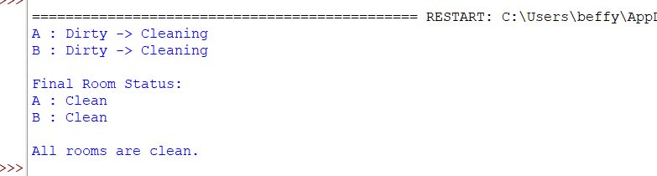

RESULT:
Thus, the Python program to solve the Vacuum Cleaner Problem was successfully implemented and executed, and both rooms were cleaned successfully.

7.Write a Python Program to Implement BFS?

AIM:
To write a Python program to implement the Breadth-First Search (BFS) algorithm for graph traversal.
ALGORITHM:
- Create a graph using an adjacency list.
- Select the starting node.
- Mark the starting node as visited and add it to a queue.
- Remove a node from the queue and display it.
- Visit all its unvisited adjacent nodes and add them to the queue.
- Repeat Steps 4 and 5 until the queue becomes empty.
- Display the BFS traversal.
CODE:
from collections import deque
graph = {
'A': ['B', 'C'],
'B': ['D', 'E'],
'C': ['F'],
'D': [],
'E': ['F'],
'F': []
}
visited = set()
queue = deque()

start = 'A'
visited.add(start)
queue.append(start)
print("BFS Traversal:")
while queue:
node = queue.popleft()
print(node, end=" ")
for neighbour in graph[node]:
if neighbour not in visited:
visited.add(neighbour)
queue.append(neighbour)
OUTPUT:

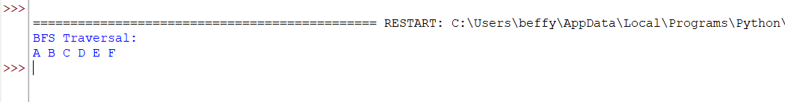

RESULT:
Thus, the Python program to implement the Breadth-First Search (BFS) algorithm was successfully executed, and the graph was traversed in breadth-first order.

8.Write a Python Program to Implement DFS?

AIM:
To write a Python program to implement the Depth-First Search (DFS) algorithm for graph traversal.
ALGORITHM:
- Create a graph using an adjacency list.
- Select the starting node.
- Mark the starting node as visited.
- Display the current node.
- Recursively visit all unvisited adjacent nodes.
- Repeat the process until all reachable nodes are visited.
- Display the DFS traversal.
CODE:
graph = {
'A': ['B', 'C'],
'B': ['D', 'E'],
'C': ['F'],
'D': [],
'E': ['F'],
'F': []
}
visited = set()
def dfs(node):
if node not in visited:
print(node, end=" ")
visited.add(node)
for neighbour in graph[node]:
dfs(neighbour)
print("DFS Traversal:")
dfs('A')
OUTPUT:

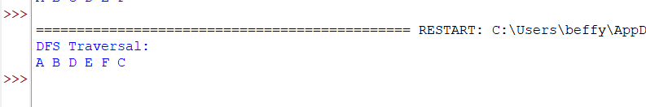

RESULT:
Thus, the Python program to implement the Depth-First Search (DFS) algorithm was successfully executed, and the graph was traversed in depth-first order.

9.Write a Python to Implement Travelling Salesman Problem?

AIM:
To write a Python program to solve the Travelling Salesman Problem (TSP) by finding the minimum-cost route that visits each city exactly once and returns to the starting city.
ALGORITHM:
- Define the distance matrix between all cities.
- Select the starting city.
- Generate all possible routes using permutations.
- Calculate the total distance for each route.
- Compare the distances of all routes.
- Select the route with the minimum total distance.
- Display the optimal route and its minimum cost.
CODE:
from itertools import permutations
graph = [
[0, 10, 15, 20],
[10, 0, 35, 25],
[15, 35, 0, 30],
[20, 25, 30, 0]
]
n = len(graph)
cities = range(1, n)
min_cost = float('inf')
best_path = ()
for path in permutations(cities):
cost = 0
current = 0
for city in path:
cost += graph[current][city]
current = city
cost += graph[current][0]
if cost < min_cost:
min_cost = cost
best_path = (0,) + path + (0,)
print("Minimum Cost:", min_cost)
print("Optimal Path:", best_path)

OUTPUT:
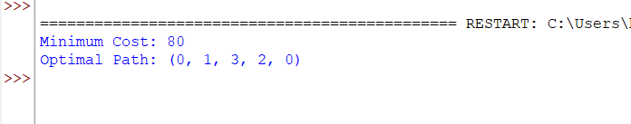

RESULT:
Thus, the Python program to solve the Travelling Salesman Problem (TSP) was successfully implemented and executed, and the optimal path with the minimum travel cost was obtained.

10.Write a Python Program to Implement A*Algorithm?

AIM:
To write a Python program to implement the A* (A-Star) Search Algorithm to find the shortest path between a start node and a goal node.
AIGORITHM:
- Define the graph with nodes and edge costs.
- Assign heuristic values to each node.
- Initialize the open list with the start node.
- Select the node with the lowest f(n) = g(n) + h(n) value.
- Expand the selected node and calculate the cost of its neighboring nodes.
- Update the open list with unvisited neighbors.
- Repeat the process until the goal node is reached.
- Display the shortest path and its total cost.
CODE:
graph = {
'A': [('B', 1), ('C', 3)],
'B': [('D', 3), ('E', 6)],
'C': [('F', 5)],
'D': [('G', 2)],
'E': [('G', 1)],
'F': [('G', 2)],
'G': []
}

heuristic = {
'A': 7,
'B': 6,
'C': 4,
'D': 2,
'E': 1,
'F': 2,
'G': 0
}
open_list = [('A', 0)]
closed_list = set()
parent = {'A': None}
cost = {'A': 0}
while open_list:
open_list.sort(key=lambda x: cost[x[0]] + heuristic[x[0]])
current = open_list.pop(0)[0]
if current == 'G':
break
closed_list.add(current)
for neighbor, weight in graph[current]:
new_cost = cost[current] + weight
if neighbor not in cost or new_cost < cost[neighbor]:
cost[neighbor] = new_cost
parent[neighbor] = current
if neighbor not in closed_list:
open_list.append((neighbor, new_cost))
path = []
node = 'G'
while node is not None:
path.append(node)
node = parent[node]
path.reverse()
print("Shortest Path:", " -> ".join(path))
print("Total Cost:", cost['G'])
OUTPUT:
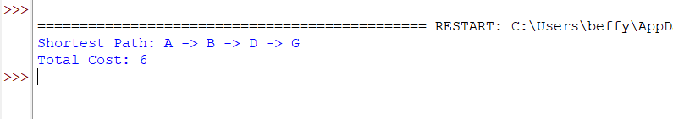

RESULT:

